ABOUT US PAGE

HEADER

OUR MISSION
Literature for Everyone
Libreya was founded with a simple yet powerful vision: to make the world’s greatest literary works accessible to everyone, everywhere, at no cost. We believe that classic literature is a shared heritage that belongs to all of humanity, not just those who can afford premium editions.
Our collection features carefully curated public domain works from the authors who shaped human thought. From the timeless plays of Shakespeare and the witty social commentary of Austen to the epic tales of Homer and the profound philosophies of Plato and Marcus Aurelius, we bring these masterpieces directly to your fingertips.
Inspired by initiatives like Project Gutenberg, we have crafted a modern, elegant reading experience that honors these classic works while making them easy to discover and enjoy on any device.

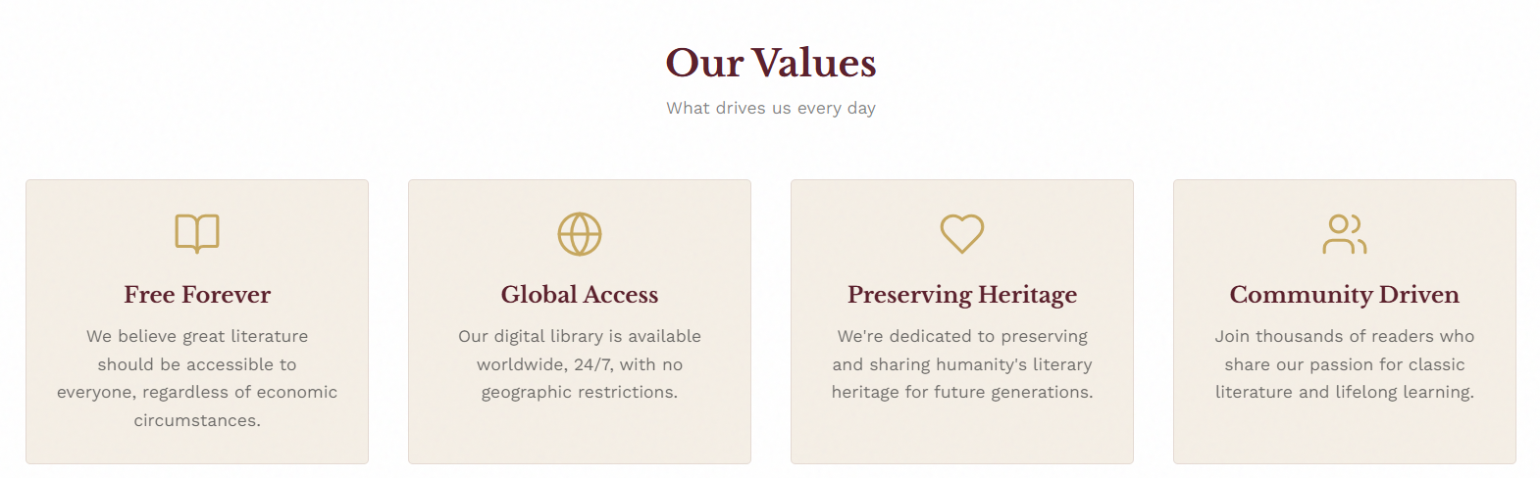
Our Values
What drives us every day

Free Forever
We believe great literature should be accessible to everyone, regardless of economic circumstances.
Global Access
Our digital library is available worldwide, 24/7, with no geographic restrictions.
Preserving Heritage
We're dedicated to preserving and sharing humanity's literary heritage for future generations.
Community Driven
Join thousands of readers who share our passion for classic literature and lifelong learning.

The Philosophy
At Libreya, we believe great literature should feel alive, not archived. In a world of endless scrolling and fragmented attention, classic books deserve a quieter space—one that invites focus, reflection, and depth.
Libreya is not a content dump; it is a curated library.
- Intentional, not overwhelming.
- Timeless, not loud.
The Reader We Serve
Libreya is for readers who move with intention:
- For those who believe great books deserve focus, not distraction.
- For students who seek clarity.
- For thinkers who return to the classics out of curiosity, not obligation.
- For modern readers who crave depth in a world designed for speed.
Libreya readers value:
- Substance over noise.
- Design that respects attention.
- Literature that endures.

Why Libreya Exists
Most digital reading experiences overwhelm the user with thousands of titles, cluttered interfaces, and distracting elements competing for attention.
Libreya takes a different approach: We curate.
Instead of offering everything, we offer what matters. Instead of noise, we create calm. Instead of distraction, we design for depth. Libreya is not built for endless scrolling; it is built for intentional reading.
What Makes Us Different
- A Curated Selection: A handpicked library of timeless classics.
- Minimalist Experience: An editorial design focused on readability.
- Personalized Tools: Highlighting and favorites to make every book your own.
- Seamless Continuity: Resume reading across all your devices.
- Focus-Driven: Designed for immersion, not stimulation.

Frequently Asked Questions
Are all books really free?
Yes! All books in our collection are in the public domain, meaning their copyrights have expired. You can read, download, and share them freely.
Do I need to create an account?
An account is not necessary but if you want to be able to move from one device to another without losing your favorites, having an account is recommended. You can also just sign in as guest and simply browse our collection and start reading or downloading immediately.
How can I suggest a book?
We're always looking to expand our collection. Reach out via our social media channels with your suggestions for classic works you'd like to see.

Ready to Start Reading?
Explore our collection of classic literature and discover your next favorite book.

